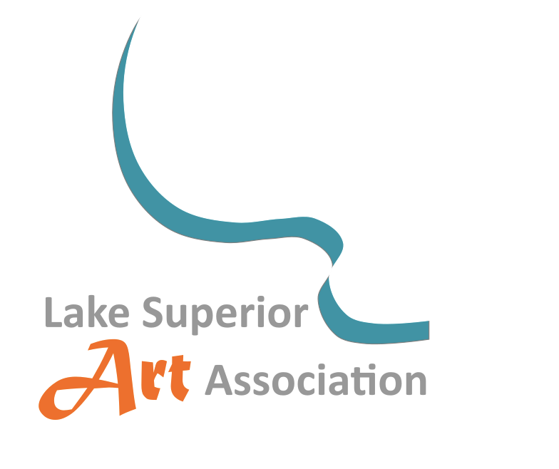
2026 LSAA Members’ Art Exhibition
October 5 to December 5, 2026
The Deo Gallery, Peter White Public Library

Entry qualifications:
- LSAA Dues must be current
- Members may enter 1 piece, original, no AI
- 2-D or 3-D, any media allowed
- All 2-D works must be gallery-hanging ready (No sawtooth hangers)
Dates:
- Drop off works at the Deo Gallery Saturday October 3rd, 10:00 am - 1:00 pm
- Awards Reception October 9, 6:00 - 8:00 pm
- Exhibition close: pick up work December 5, 10:00 am – 2:00 pm
- All work must be picked up on December 5th !

Questions: email LSAAinfo4u@gmail.com

Registration Form 2026 LSAA Members’ Art Exhibition

Artist Name:_________________________________________________
Address: ____________________________________________________
Phone: ______________________________________________________
Email: _______________________________________________________
Title of Work: ________________________________________________
Media: ______________________________________________________
Price or NFS: _________ First-time exhibitor? ____________________
I understand that neither LSAA, Inc nor Peter White Public Library is responsible for damage or loss to artworks.

___________________________________________
Your signature


Please place this label on the back of your work

Artist Name: ________________________________________
Phone: ______________________________________________
Title of Work: ________________________________________
Media: ______________________________________________
Price or NFS: ________ First-time exhibitor? _____________

