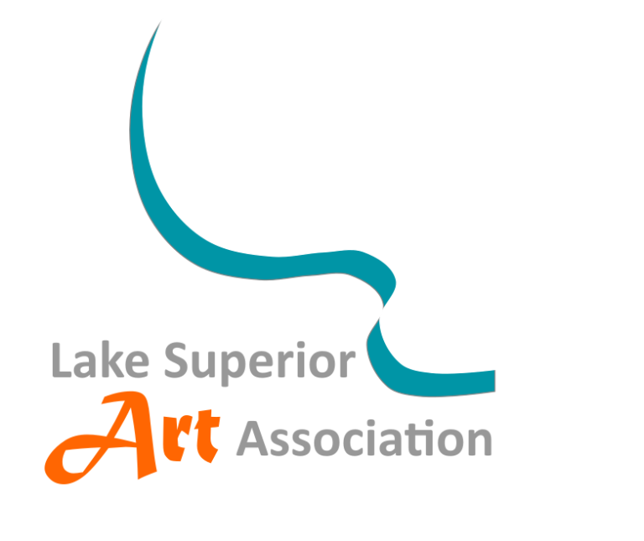
Lake Superior Art Association (LSAA, Inc.)
Participant Liability Waiver and Release of Claims
LSAA Art Tour 2026 • October 23–25, 2026

Participant Information
Participant Name: ____________________________
Address: _________________________________. City, State, ZIP: __________________________
Phone: ___________________ Email: _________________________

Assumption of Risk and Release of Liability
I understand that I am voluntarily participating in the Lake Superior Art Association (LSAA, Inc.) Art Tour taking place October 23–25, 2026, including transportation by charter bus. I acknowledge the inherent risks of travel and participation, voluntarily assume those risks, and, to the fullest extent permitted by Michigan law, release and hold harmless LSAA, Inc., its officers, directors, members, volunteers, employees, agents, representatives, sponsors, and event organizers from claims arising out of my participation, except for claims based on gross negligence, reckless conduct, or intentional misconduct.

Medical Responsibility
I certify that I am physically able to participate. If emergency treatment is reasonably necessary, I authorize emergency personnel to provide treatment and accept responsibility for related expenses.

Personal Property
LSAA is not responsible for the loss, theft, or damage of my personal belongings during the trip.

Photography Release
I grant LSAA permission to use photographs or recordings of me for nonprofit purposes without compensation.
☐ I prefer not to be photographed.

Participant Conduct
I agree to follow reasonable instructions from LSAA representatives, bus personnel, and venue staff.

Governing Law
This Agreement shall be governed by the laws of the State of Michigan.

Acknowledgment
I have read and understand this Agreement, understand the rights I am waiving, and sign voluntarily.
Participant Signature: ________________________________
Printed Name: _______________________________________
Date: ____________________

