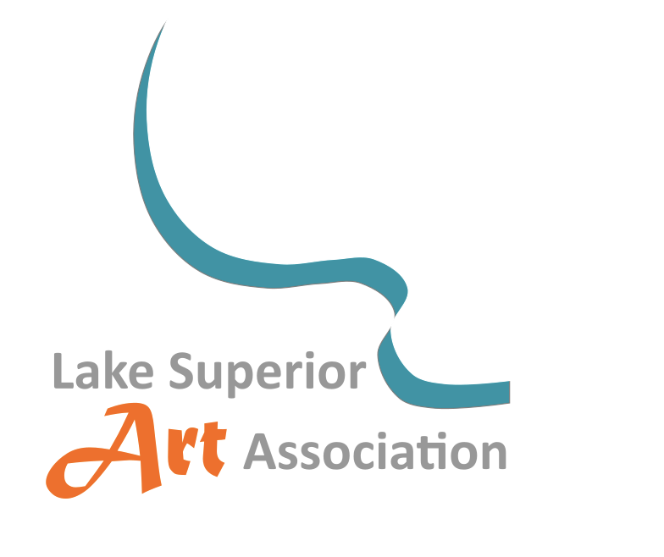
Lake Superior Art Association (LSAA, Inc.)
LSAA Visual Arts Grant Policy
LSAA’s mission is to promote and encourage development of visual arts and artists in the Marquette County area through programs and services directed towards appreciation of and participation in the visual arts. LSAA has established a program to provide grants for any person, group, or organization in the county that needs financial assistance to purchase art supplies.
- All parties requesting financial support must complete the Lake Superior Art Association Grant Request Form.
- Persons applying for a grant must be 18 or older. An adult may request a grant for a child’s art materials.
- For-profit organizations may not request an LSAA grant.
- Grant money may only be used to purchase art supplies, not to pay wages or fees.
- Grant money must be spent entirely on the proposed program or activity described in the application.
- The deadline for grant submissions is November 15th of each year. Grant requesters will be notified during the month of January, if their requests have been accepted or not.
- LSAA has authorized a pool of up to $5,000.00 to be distributed among the parties who request grants, and reserves the option to adjust the awarded amount to each grantee.
- Within a year of receiving an LSAA grant, recipients are required to submit a final summary, stating how the grant was spent. If possible, please include photos. This summary can be mailed to LSAA PO Box 9 Marquette, MI 49855 or emailed to lsaainfo4u@gmail.com.
- All requests can be kept confidential, with only LSAA’s Grant Committee permitted to read the requests, if this choice is indicated on the application form.
For more information, please contact LSAA at: lsaainfo4u@gmail.com

Lake Superior Art Association Grant Request Form
Date of Application: _________________
Request is for: ____ Organization/School ____ Individual ____ Adult, for a child
Is the Requester 18 or older? ___________
Name of Organization or Individual: ________________________________________________
Mailing Address: _______________________________________________________________
Phone Number: ______________________Email address: ______________________________
Purpose of Grant and who will benefit from it: ______________________________________________________________________________
__________________________________________________________________________________________________________________________________________________________________________________________________________________________________________
Amount Requested: $_____________
Photos that I submit may be used by LSAA for its newsletter, The Kiosk. ____Yes ____No
I would like this request to be kept confidential. ____Yes ____No
Upon acceptance, who should the check be written out to? _____________________________
Mailing address for check: ________________________________________________________
Additional Comments: ___________________________________________________________
______________________________________________________________________________
Deadline for submitting a grant request is November 15th of each year
For more information, please contact LSAA at: lsaainfo4u@gmail.com
Please send this completed form to:
LSAA, Inc. PO Box 9 Marquette, MI 49855

